Tabari Harvey Module 7.2 Assignment

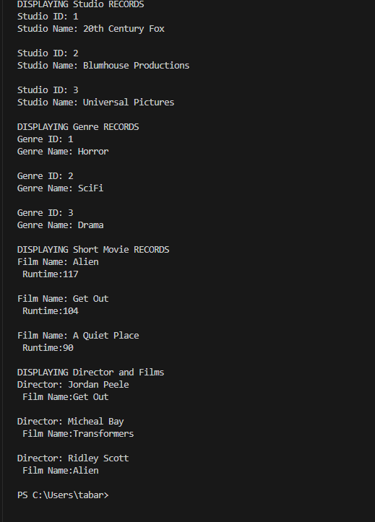

<https://github.com/MurphT4stic?tab=repositories>